DAA – Question Bank

Unit - 4

Q.No Questions Marks 1. Write an algorithm to find the shortest path in a multi stage graph using dynamic 7M

programming using forward approach?



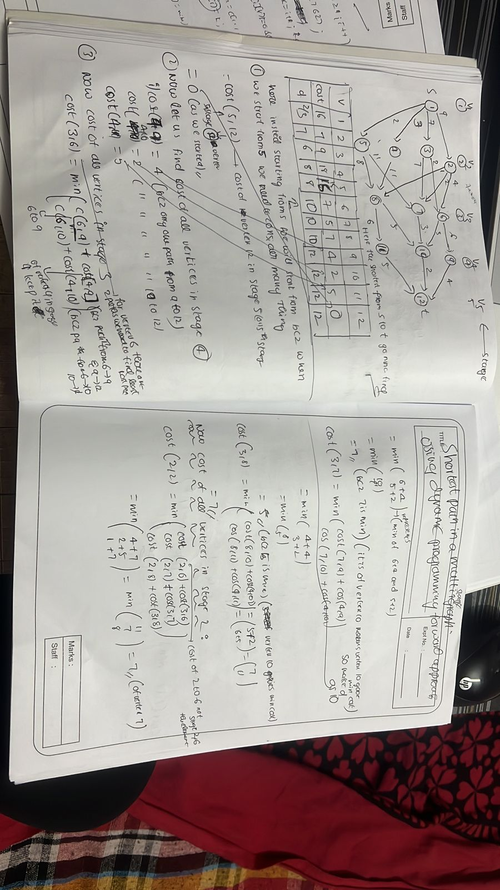

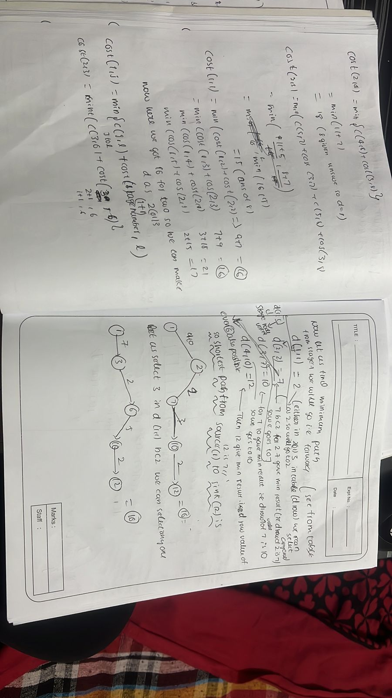

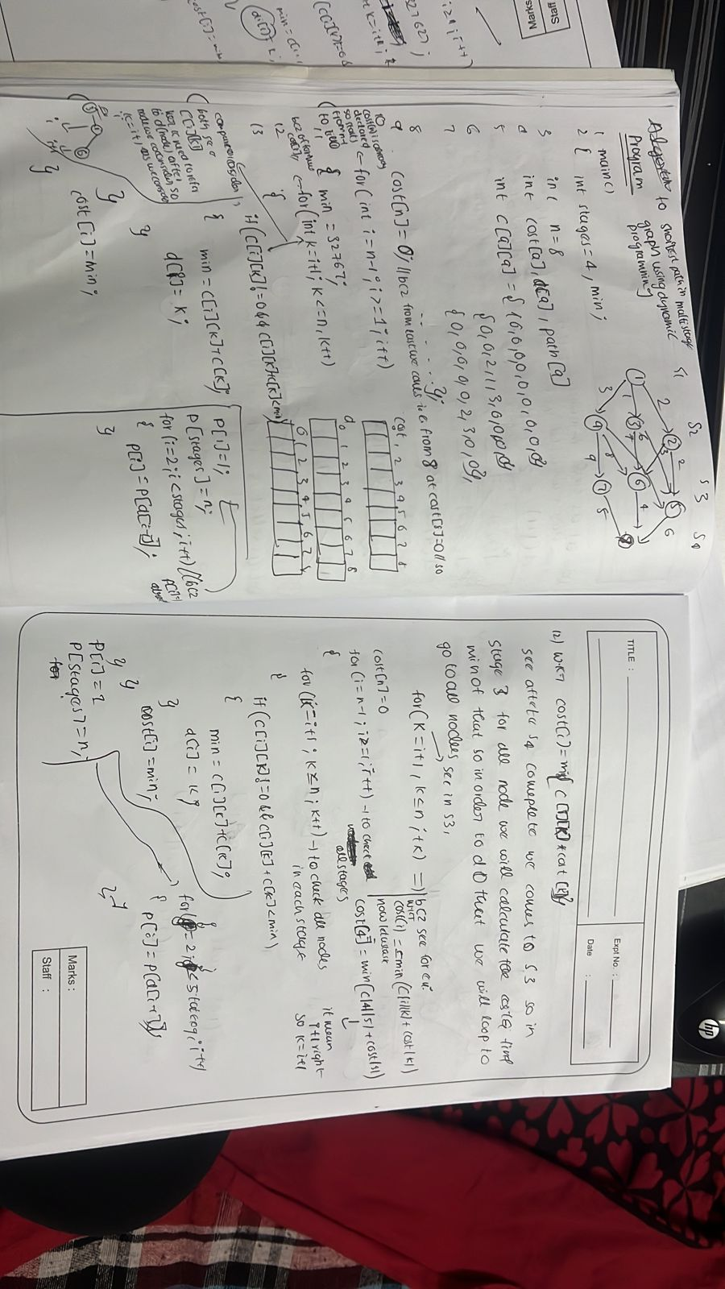

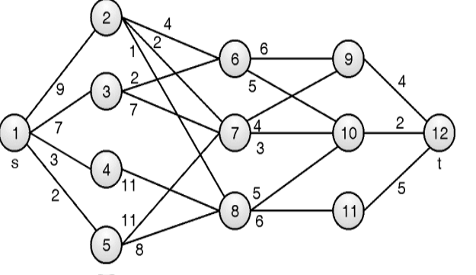2. Find minimum path cost between vertex s and t for following multistage graph 10M using dynamic programming.

DAA – Question Bank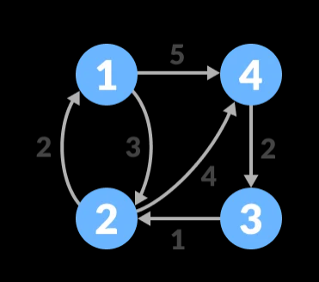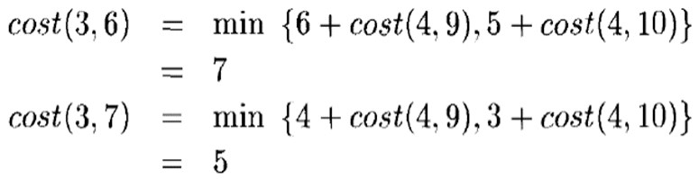

Solution to multistage graph using dynamic programming is constructed as, Cost[j] = min{c[j, r] + cost[r]}

Here, number of stages k = 5, number of vertices n = 12, source s = 1 and target t = 12

Initialization:

Cost[n] = 0 ⇒ Cost[12] = 0. p[1] = s ⇒ p[1] = 1

p[k] = t ⇒ p[5] = 12. r = t = 12.

Stage 4: cost(5,12)=0

cost(4,9)=c(9,12) = 4 cost(4,10)=c(10,12)=2 cost(4,11)=c(11,12)=5

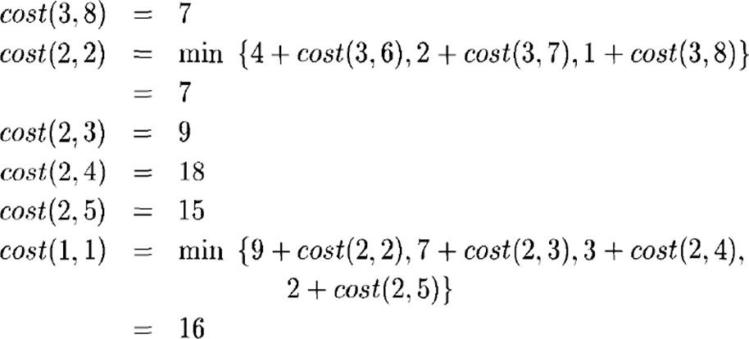**Minimum cost path is : 1 – 2 – 7 – 10 – 12 Cost of the path is : 9 + 2 + 3 + 2 = 16**

3. Apply Floyd’s algorithm for constructing the all pairs shortest path for the 7M following graph.

Answer:

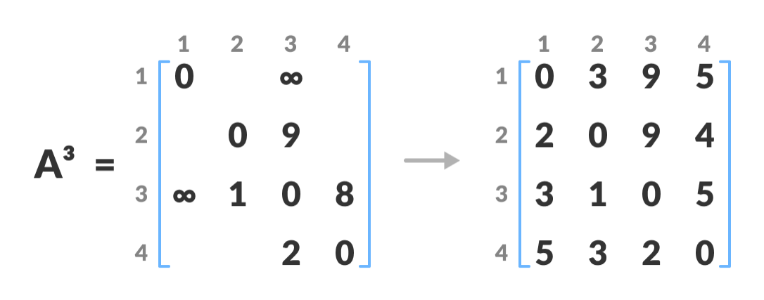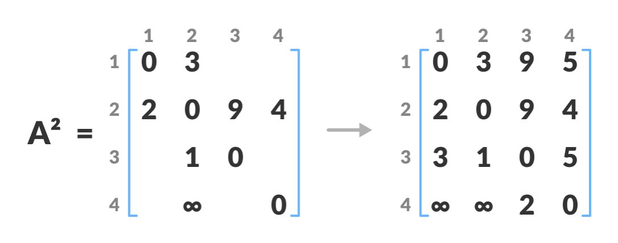DAA – Question Bank

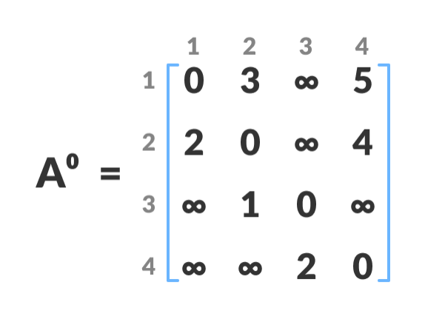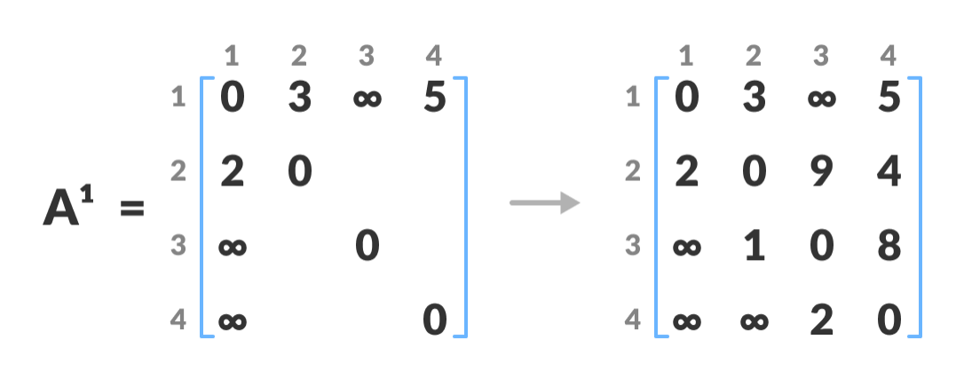

DAA – Question Bank

4. Using Dijkstra’s Algorithm, find the shortest distance from source vertex ‘A’ to 10M remaining vertices in the following graph

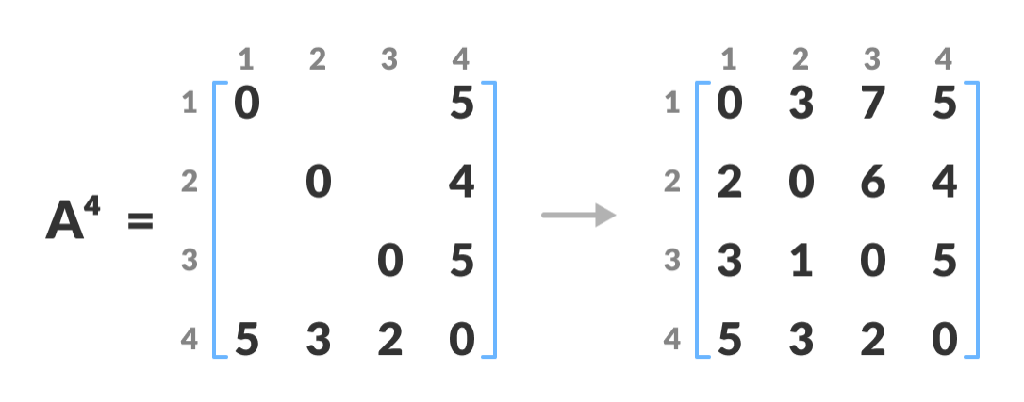

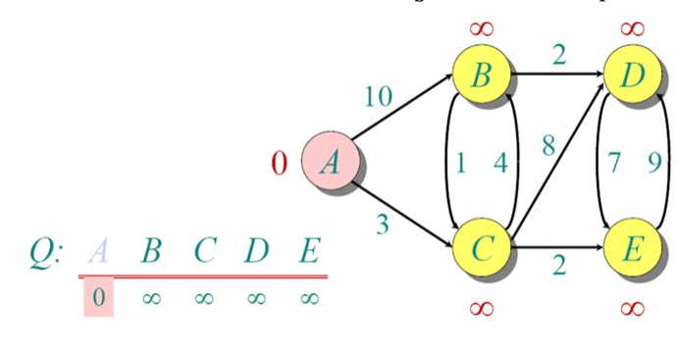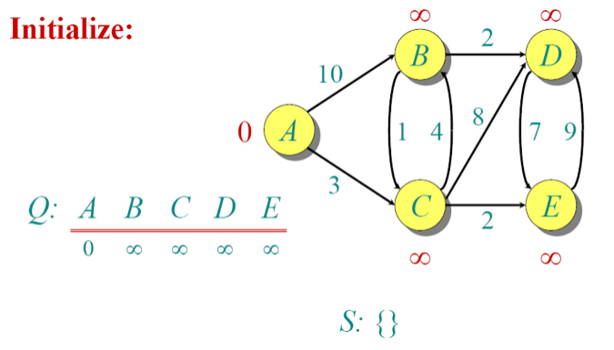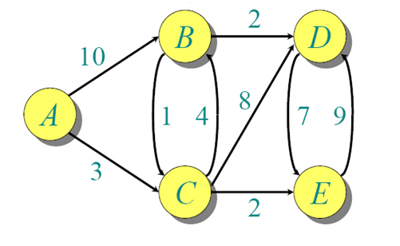Answer:

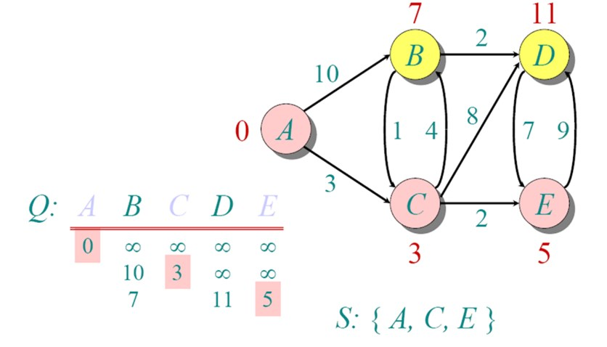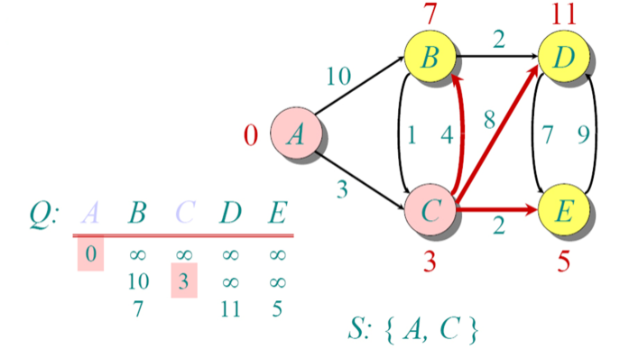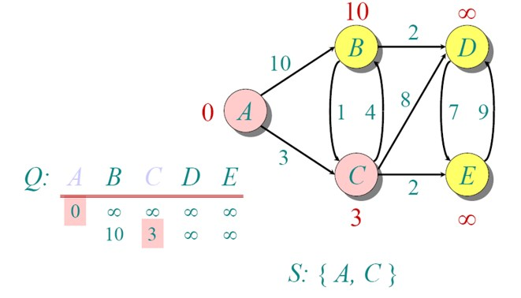DAA – Question Bank

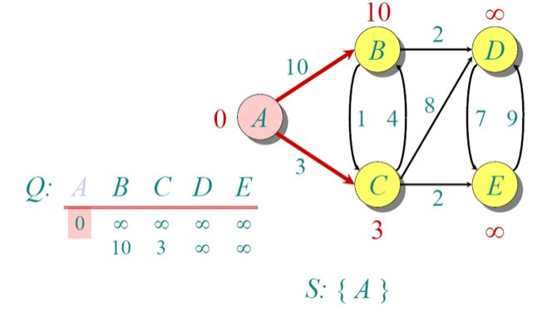

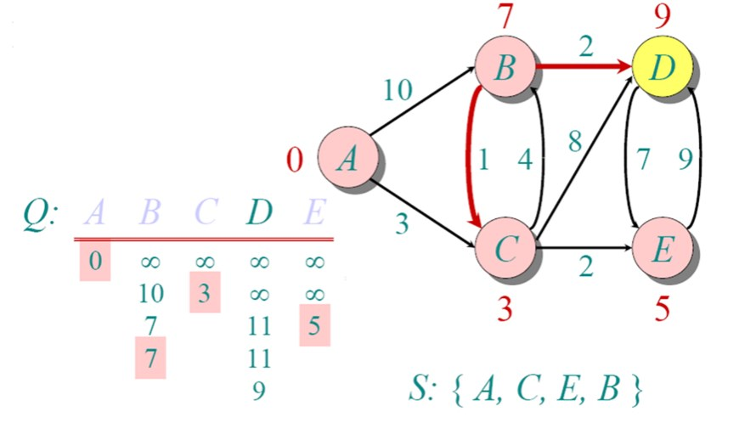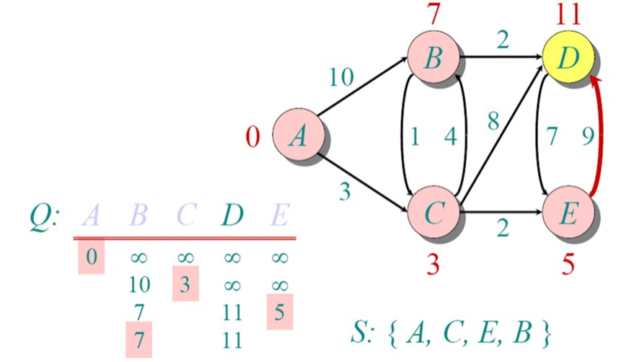DAA – Question Bank

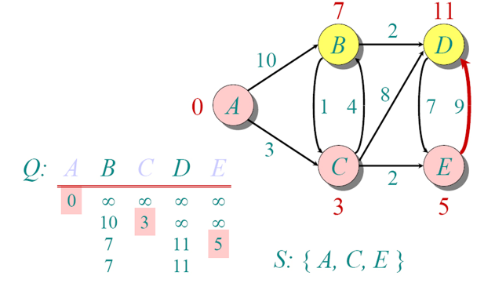

DAA – Question Bank

Shortest Path: A,C,E,B,D

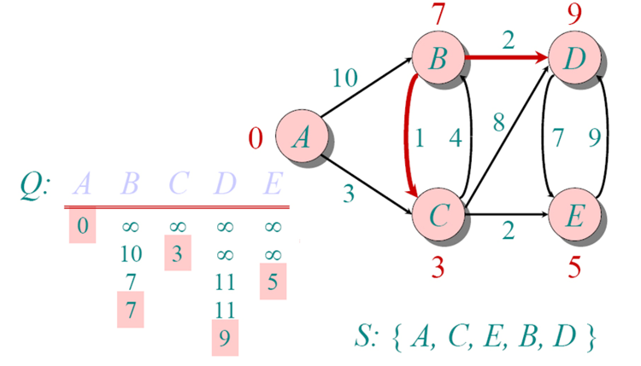

5. Write an algorithm to find the single source shortest paths in a dynamic 4M programming using Dijkstra's Algorithm?

dist[s] ←0

for all v ∈ V–{s}

do dist[v] ←∞ S←∅

Q←V

(distance to source vertex is zero)

(set all other distances to infinity)

(S, the set of visited vertices is initially empty) (Q, the queue initially contains all vertices)

while Q ≠∅ (while the queue is not empty)

do u ← mindistance(Q,dist) (select the element of Q with the min. distance)

S←S∪{u} (add u to list of visited vertices) for all v ∈ neighbors[u]

do if dist[v] > dist[u] + w(u, v) (if new shortest path found) then d[v] ←d[u] + w(u, v) (set new value of shortest

path)

(if desired, add traceback code) return dist

6.

Construct an optimal binary search tree over five key values 14M k1 < k2 < k3 < k4 < k5 with access probability 0.3, 0.2, 0.1,

0.15, and 0.25, respectively.

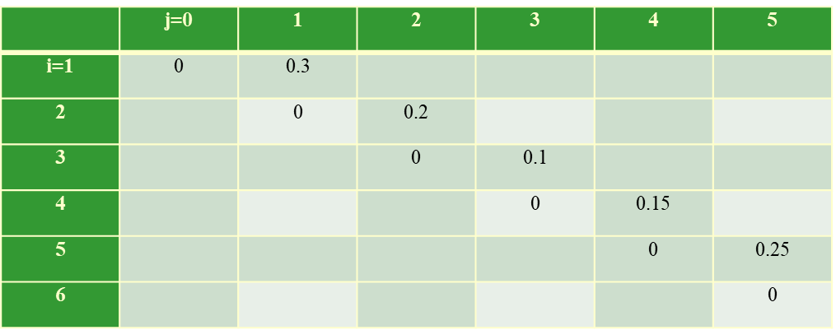Solution

DAA – Question Bank Cost Table: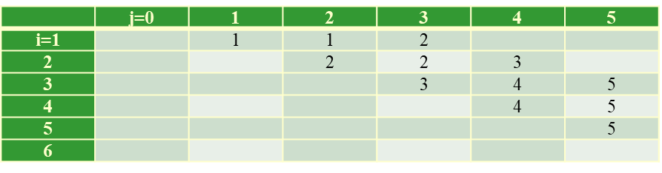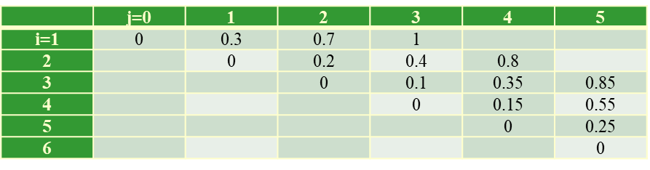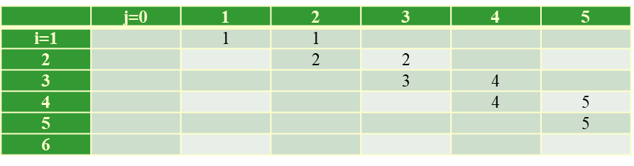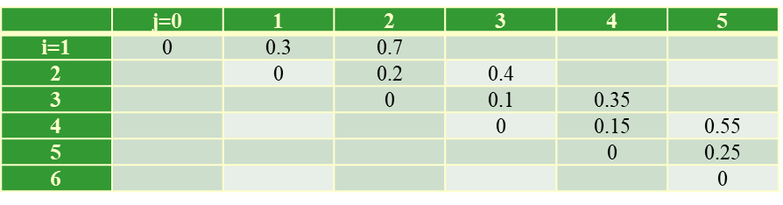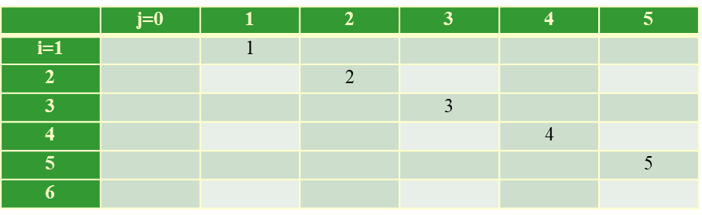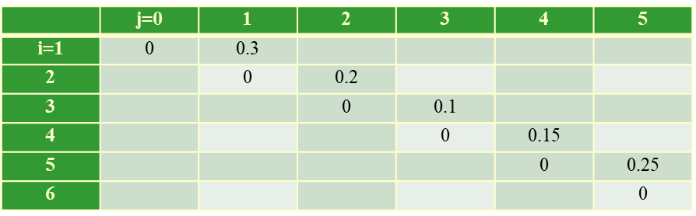

Root:

Cost Table:

Root:

Cost:

Root:

Cost:

DAA – Question Bank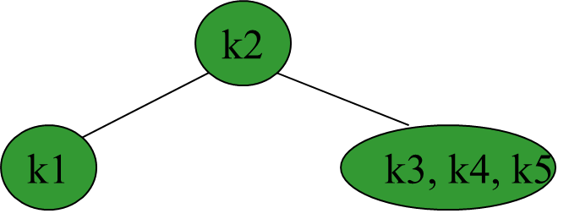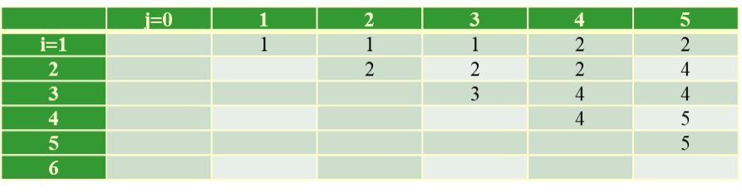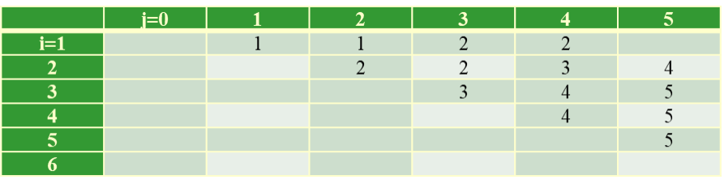

Root:

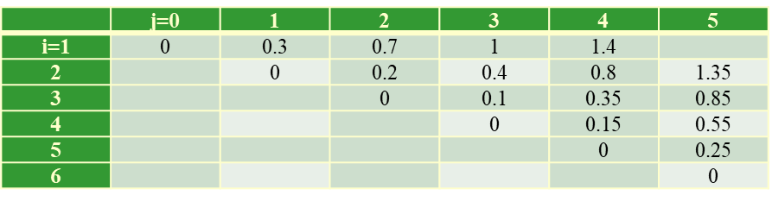

Cost:

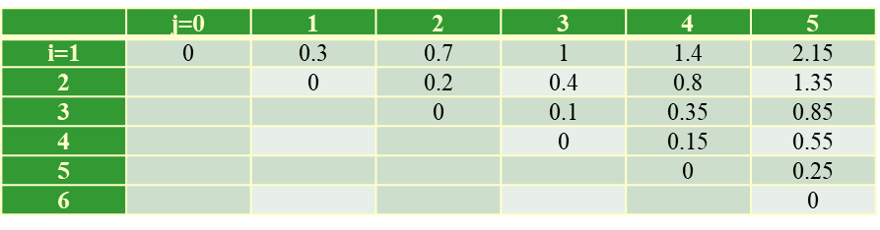Root:

r[1, 5] = 2 shows that the root of the tree over k1, k2, k3, k4, k5 is k2

r[3, 5] = 4 shows that the root of the subtree over k3, k4, k5 is k4.

DAA – Question Bank

7. Find an optimal solution for following 0/1 Knapsack problem using dynamic 14M programming: Number of objects n = 4, Knapsack Capacity M = 5, Weights (W1,

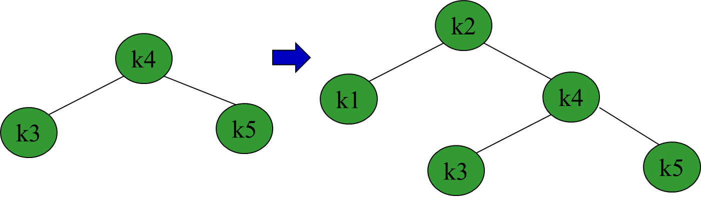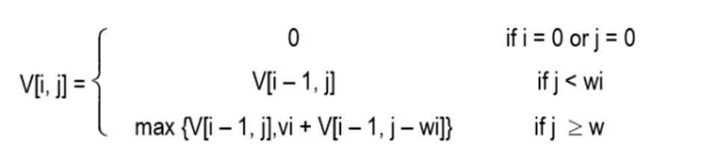

W2, W3, W4) = (2, 3, 4, 5) and profits (P1, P2, P3, P4) = (3, 4, 5, 6).

**Solution**

Solution of the knapsack problem is defined as

**Ite** **Weight** **Value m** **(wi)** **(vi)**

I1 2 3

I2 3 4

I3 4 5

I4 5 6

Filling first column, j = 1

V [1, 1] ⇒ i = 1, j = 1, wi = w1 = 2 As, j < wi, V [i, j] = V [i – 1, j]

V [1, 1] = V [0, 1] = 0

V [2, 1] ⇒ i = 2, j = 1, wi = w2 = 3 As, j < wi, V [i, j] = V [i – 1, j]

V [2, 1] = V [1, 1] = 0

V [3, 1] ⇒ i = 3, j = 1, wi = w3 = 4 As, j < wi, V [i, j] = V [i – 1, j]

V [3, 1] = V [2, 1] = 0

V [4, 1] ⇒ i = 4, j = 1, wi = w4 = 5 As, j < wi, V[i, j] = V[i – 1, j]

DAA – Question Bank V [4, 1] = V [3, 1] = 0 Filling first column, j = 2

V[1, 2] ⇒ i = 1, j = 2, wi = w1 = 2, vi = 3

As, j ≥ wi, V [i, j]=max {V [i – 1, j], vi + V[i – 1, j – wi] } = max {V [0, 2], 3 + V [0, 0]}

V[1, 2] = max (0, 3) = 3

V[2, 2] ⇒ i = 2, j = 2, wi = w2 = 3, vi = 4 As, j < wi, V [i, j] = V[i – 1, j]

V[2, 2] = V[1, 2] = 3

V[3, 2] ⇒ i = 3, j = 2, wi = w3 = 4, vi = 5 As, j < wi, V[i, j] = V[i – 1, j]

V[3, 2] = V [2, 2] = 3

V[4, 2] ⇒ i = 4, j = 2, wi = w4 = 5, vi = 6 As, j < wi, V[i, j] = V[i – 1, j]

V[4, 2] = V[3, 2] = 3

Filling first column, j = 3

V[1, 3] ⇒ i = 1, j = 3, wi = w1 = 2, vi = 3

As, j ≥ wi, V [i, j]=max {V [i – 1, j], vi + V [i – 1, j – wi] } = max {V [0, 3], 3 + V [0, 1]}

V[1, 3] = max (0, 3) = 3

V[2, 3] ⇒ i = 2, j = 3, wi = w2 = 3, vi = 4

As, j ≥ wi, V [i, j] = max {V [i – 1, j], vi + V [i – 1, j – wi] } = max {V [1, 3], 4 + V [1, 0]}

V[2, 3] = max (3, 4) = 4

V[3, 3] ⇒ i = 3, j = 3, wi = w3 = 4, vi = 5 As, j < wi, V [i, j] = V [i – 1, j]

V[3, 3] = V [2, 3] = 4

V[4, 3] ⇒ i = 4, j = 3, wi = w4 = 5, vi = 6 As, j < wi, V[i, j] = V[i – 1, j]

V[4, 3] = V [3, 3] = 4

Filling first column, j = 4

V[1, 4] ⇒ i = 1, j = 4, wi = w1 = 2, vi = 3

As, j ≥ wi, V [i, j]=max {V [i – 1, j], vi + V [i – 1, j – wi] } = max {V [0, 4], 3 + V [0, 2]}

V[1, 4] = max (0, 3) = 3

V[2, 4] ⇒ i = 2, j = 4, wi = w2 = 3 , vi = 4

As, j ≥ wi, V [i, j] =max {V [i – 1, j], vi + V [i – 1, j – wi] } = max {V [1, 4], 4 + V [1, 1]}

V[2, 4] = max (3, 4 + 0) = 4

V[3, 4] ⇒ i = 3, j = 4, wi = w3 = 4, vi = 5

As, j ≥ wi, V [i, j]=max {V [i – 1, j], vi + V [i – 1, j – wi] } = max {V [2, 4], 5 + V [2, 0]}

V[3, 4] = max (4, 5 + 0) = 5

V[4, 4] ⇒ i = 4, j = 4, wi = w4 = 5, vi = 6 As, j < wi, V [i, j] = V [i – 1, j]

V[4, 4] = V [3, 4] = 5

DAA – Question Bank

g l =

5 1 = v 3 ≥ [ m { i

x 5 V 5 ( =

5 2 w = v 4

≥ [ m { j + [ x 5 V

5 ( 3

5 3 = v 5

≥ i m { j + [ x 5 V

5 ( 0

5 = w w = i ≥ [ m { i

x 5 V 5 ( 0

1, j – wi] }

, j – wi] }

, j – wi] }

1, j – wi] }

i = 3

i = 4

w3= v3 4 =5

w4= v4 5 =6

0 0 3 4 5 7

0 0 3 4 5 7

Find selected items for M = 5

DAA – Question Bank

Step 1 : Initially, i = n = 4, j = M = 5 V[i, j] = V[4, 5] = 7

V[i – 1, j] = V[3, 5] = 7

V[i, j] = V[i – 1, j], so don’t select ith item and check for the previous item. so i = i – 1 = 4 – 1 = 3

Solution Set S = { }

Step 2 : i = 3, j = 5 V[i, j] = V[3, 5] = 7

V[i – 1, j] = V[2, 5] = 7

V[i, j] = V[i – 1, j], so don’t select ith item and check for the previous item. so i = i – 1 = 3 – 1 = 2

Solution Set S = { } Step 3 : i = 2, j = 5 V[i, j] = V[2, 5] = 7

V[i – 1, j] = V[1, 5] = 3

V[i, j] ≠ V[i – 1, j], so add item Ii = I2 in solution set. Reduce problem size j by wi

j = j – wi = j – w2 = 5 – 3 = 2 i = i – 1 = 2 – 1 = 1

Solution Set S = {I2}

Step 4 : i = 1, j = 2 V[1, j] = V[1, 2] = 3 V[i – 1, j] = V[0, 2] = 0

V[i, j] ≠ V[i – 1, j], so add item Ii = I1 in solution set. Reduce problem size j by wi

j = j – wi = j – w1 = 2 – 2 = 0 Solution Set S = {I1, I2}

**Problem size has reached to 0, so final solution is S = {I1, I2} Earned profit = P1 + P2 = 7**

8. Write an algorithm to find the shortest path in a Bellman-Ford Algorithm using 4M dynamic programming.

function bellmanFord(G, S)

for each vertex V in G

distance[V] <- infinite

previous[V] <- NULL

distance[S] <- 0

for each vertex V in G

for each edge (U,V) in G

if distance[V] < distance[U] + c(U, V)

distance[V] <- distance[U] + c(U, V) //or distance[U] +edge_weight(U, V)

previous[V] <- U

for each edge (U,V) in G

If distance[U] + c(U, V) < distance[V}

Error: Negative Cycle Exists

return distance[], previous[]

9. Consider the weighted graph below. Find out the minimum shortest path using 10M bellman ford algorithm. Find out whether the given graph is negative cycle or

without negative cycle.

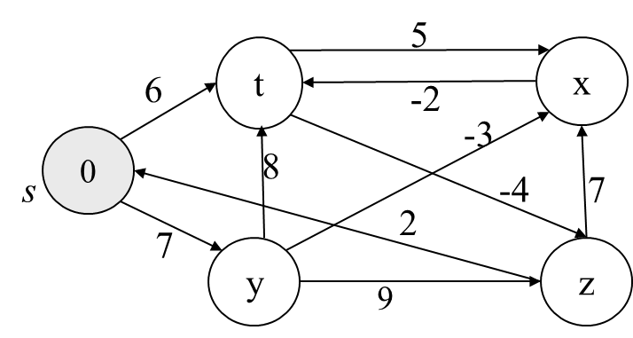Solution:

Assume that S is our starting vertex. We’re now ready to start with the initialization step of the algorithm:

Relaxing all edges n-1 times, (where n is no. of vertex) Relaxation: if (d[u]+c[u,v]<d[v])

d[v]=d[u]+c[u,v]

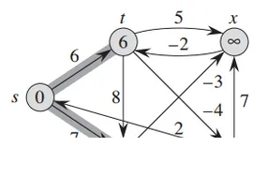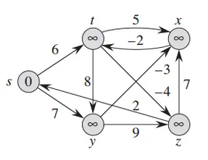Edge List: (s,t) = 6 (y,x) = -3 (s,y)= 7 (y,z) = 9 (t,y) = 8 (x,t) = -2 (t,z) = -4 (z,x) = 7 (t,x) = 5 (z,s) = 2

DAA – Question Bank

Until now 4 iterations completed and shortest path found to every node form source node. Now we have to do one more iteration to find whether there exists negative edge cycle or not. When we do this nth (5th here) relaxation if we found less distance to any vertex from any other path we can say that there is negative edge cycle. Here we can relax any edge to graph which obtained in iteration 4and we can observe that there is no chance to change those values. So we can confirm that there is no negative edge cycle in this graph.

DAA – Question Bank

Solve the traveling salesman problem by given graph using dynamic programming. 10M

Solution:

1 2 3 4 1 0 10 15 20 2 5 0 9 10 3 6 13 0 12 4 8 8 9 0

S = Φ Cost(2,Φ,1)=d(2,1)=5Cost(2,Φ,1)=d(2,1)=5 Cost(3,Φ,1)=d(3,1)=6Cost(3,Φ,1)=d(3,1)=6 Cost(4,Φ,1)=d(4,1)=8Cost(4,Φ,1)=d(4,1)=8

S = 1

Cost(i,s)=min{Cost(j,s–(j))+d[i,j]}Cost(i,s)=min{Cost(j,s)−(j))+d[i,j]}

Cost(2,{3},1)=d[2,3]+Cost(3,Φ,1)=9+6=15cost(2,{3},1)=d[2,3]+cost(3,Φ,1)=9+6= 15 Cost(2,{4},1)=d[2,4]+Cost(4,Φ,1)=10+8=18cost(2,{4},1)=d[2,4]+cost(4,Φ,1)=10+ 8=18

Cost(3,{2},1)=d[3,2]+Cost(2,Φ,1)=13+5=18cost(3,{2},1)=d[3,2]+cost(2,Φ,1)=13+ 5=18 Cost(3,{4},1)=d[3,4]+Cost(4,Φ,1)=12+8=20cost(3,{4},1)=d[3,4]+cost(4,Φ,1)=12+ 8=20 Cost(4,{3},1)=d[4,3]+Cost(3,Φ,1)=9+6=15cost(4,{3},1)=d[4,3]+cost(3,Φ,1)=9+6= 15 Cost(4,{2},1)=d[4,2]+Cost(2,Φ,1)=8+5=13cost(4,{2},1)=d[4,2]+cost(2,Φ,1)=8+5= 13

S = 2

Cost(2,{3,4},1)= d[2,3]+Cost(3,{4},1)=9+20=29 d[2,4]+Cost(4,{3},1)=10+15=25=25Cost(2,{3,4},1) = 25 {d[2,3]+cost(3,{4},1)=9+20=29d[2,4]+Cost(4,{3},1)=10+15=25=25

DAA – Question Bank

Cost(3,{2,4},1)= d[3,2]+Cost(2,{4},1)=13+18=31 d[3,4]+Cost(4,{2},1)=12+13=25=25Cost(3,{2,4},1) = 25 {d[3,2]+cost(2,{4},1)=13+18=31d[3,4]+Cost(4,{2},1)=12+13=25=25

Cost(4,{2,3},1)= d[4,2]+Cost(2,{3},1)=8+15=23d[4,3]+Cost(3,{2},1)=9+18 =27=23Cost(4,{2,3},1){d[4,2]+cost(2,{3},1)=8+15=23d[4,3]+Cost(3,{2},1)=9+18 =27=23

S = 3

Cost(1,{2,3,4},1)= d[1,2]+Cost(2,{3,4},1)=10+25=35 d[1,3]+Cost(3,{2,4},1)=15+25=40 d[1,4]+Cost(4,{2,3},1)=20+23=43=35cost(1,{2,3,4}),1) d[1,2]+cost(2,{3,4},1)=10+25=35 d[1,3]+cost(3,{2,4},1)=15+25=40 d[1,4]+cost(4,{2,3},1)=20+23=43=35

11. Write an algorithm to find the shortest path in a Traveling-Salesman-Problem using 4M dynamic programming.

Solution:

Algorithm: Traveling-Salesman-Problem C ({1}, 1) = 0

for s = 2 to n do

for all subsets S Є {1, 2, 3, … , n} of size s and containing 1 C (S, 1) = ∞

for all j Є S and j ≠ 1

C (S, j) = min {C (S – {j}, i) + d(i, j) for i Є S and i ≠ j} Return minj C ({1, 2, 3, …, n}, j) + d(j, i)